Week 6

3. ReactJS – HOL

**• Explain React components**

React components are reusable building blocks of a React application. They return HTML using JSX and manage their own structure, behavior, and rendering.

**• Identify the differences between components and JavaScript functions**

| **Basis** | **React Components** | **JavaScript Functions** |
| --- | --- | --- |
| Purpose | UI rendering | Logic execution |
| Returns | JSX (HTML-like syntax) | Data or values |
| Life Cycle | Has lifecycle methods | No lifecycle |
| React Integration | Works with React rendering | Does not directly render to UI |

**• Identify the types of components**

1. **Class Components**
2. **Function Components**

**• Explain class component**

A class component is a React component created using ES6 classes. It has a render() method and can use lifecycle methods and state.

class MyComponent extends React.Component {

render() {

return <h1>Hello from class component</h1>;

}

}

**• Explain function component**

A function component is a simple JavaScript function that returns JSX. It can use hooks (like useState, useEffect) for state and lifecycle logic.

function MyComponent() {

return <h1>Hello from function component</h1>;

}

**• Define component constructor**

The constructor is a method in class components used to initialize state and bind event handlers.

constructor(props) {

super(props);

this.state = { count: 0 };

}

**• Define render() function**

The render() function is used in class components to return JSX that defines what should be displayed on the UI.

render() {

return <div>Welcome</div>;

}

Steps:

Create react app:-

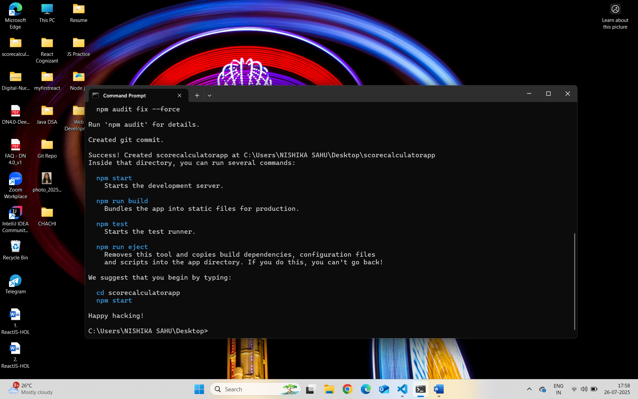

CalculateScore.js :-

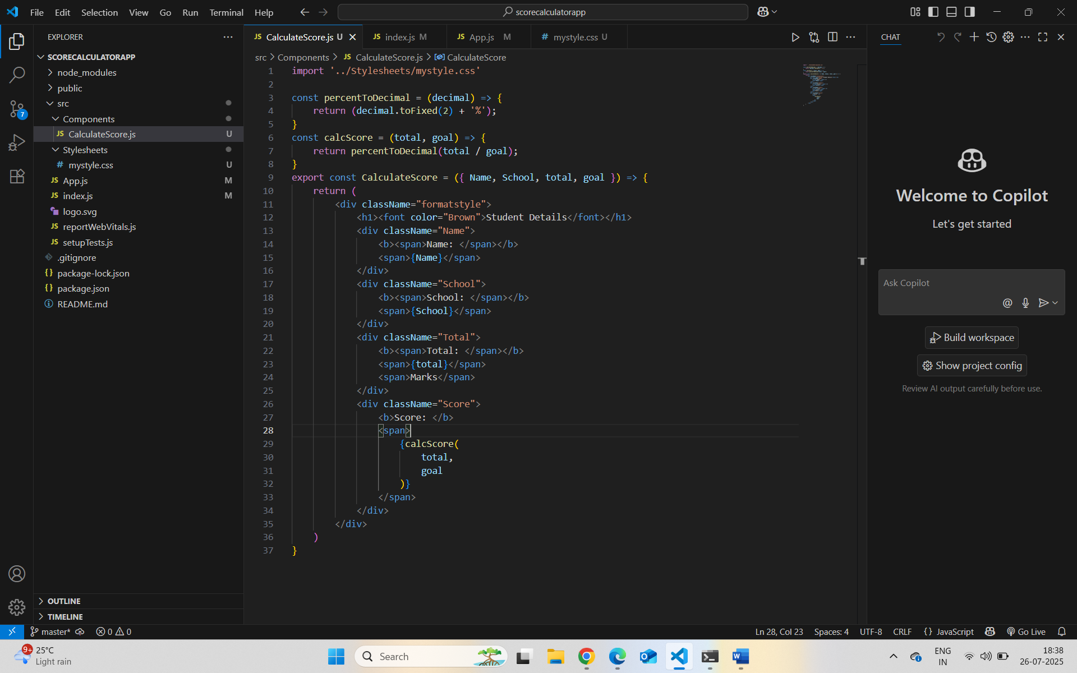

mystyle.css :-

App.js :-

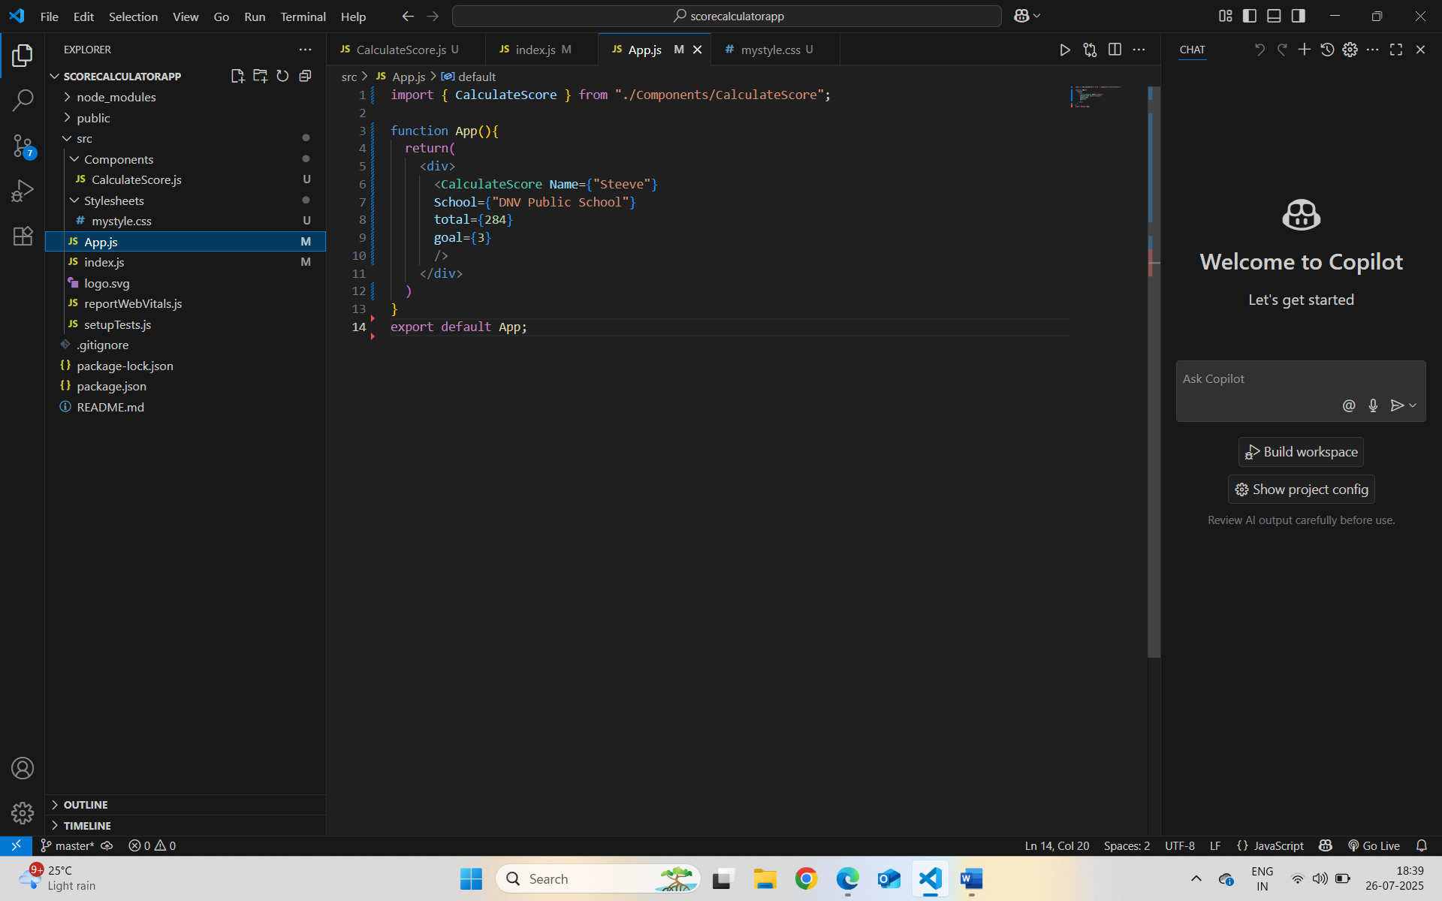

Localhost:3000 :-

